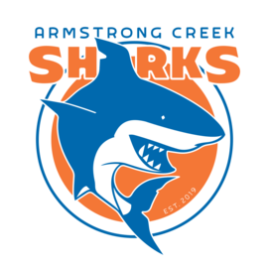
Key Armstrong Creek Football & Netball Club Facts
Established: 2019
Mascot: Shark
Home Ground: 73-93 Central Blvd, Armstrong Creek

Our Purpose
The Armstrong Creek Football & Netball Club (the club) aims to provide the best possible environment for members to feel a sense of community and be a sporting club which promotes participation, achievement and contribution.

Our Mission
The Club’s mission is to provide a supportive, respectful, inclusive club environment for Armstrong Creek and the surrounding community. Through sporting programs, the club aims to encourage, advance and assist in the development for boys and girls to realise their maximum potential and maintain their physical wellbeing. Together we will provide the opportunity to participate in sport that encourages family participation and teaches the values of discipline, commitment and teamwork that can be applied not only on the field or court, but also in life.

Our Vision
- We recognise that the club is greater than any one individual, the aspirations for our club are:
- To be an organisation that runs smoothly and professionally with quality facilities
- To have qualified and accredited coaches to develop skills and people
- For our older members to be role models for our younger junior members, both in their sporting ability and their social behaviour
- For our members to be committed to coaching, training and their team as this will aid in establishing a style of play that promotes on field success
- To have a community of playing and non-playing members who actively contribute to the club
- For the club to be acknowledged as making a contribution to the broader community
- For all members of the club to consistently display our core values
- To have the full support of local businesses who are eager to sponsor, promote and support us
- To have a stable leadership group who are positive, enthusiastic and open to change
- To have a club environment which is inclusive and a great place to be
- For our club to continue to grow with the community, and strive to be known as leaders in our league

Our Values
- Enthusiasm and Commitment
  - We train hard, play hard but most importantly have fun
  - We contribute positively both on the field/court and within the club

- Respectfulness and Accountability
  - We respect all players, officials, spectators and member
  - We maintain a high standard of personal behaviour
  - We respect the decisions of the coaches and umpires

- Teamwork and Collaboration
- We play and train as a part of a team
- We volunteer and take up roles to achieve the best outcome for the club
- We are inclusive of players of all abilities and encourage participation

- Development and Excellence
  - We win cleanly through spirit, talent and discipline
  - All players are given the opportunity to reach their potential
  - Development of all players, umpires and coaches will be a focus for our club

